**Project Development Phase**

**Delivery of Sprint - 2**

|  |  |
| --- | --- |
| **Date** | 31 October 2022 |
| **Team ID** | PNT2022TMID45108 |
| **Project Name** | AI-based discourse for Banking Industry |

**Creating Saving Account Action**

Create a saving account in IBM Watson. Create new **Action** Saving.

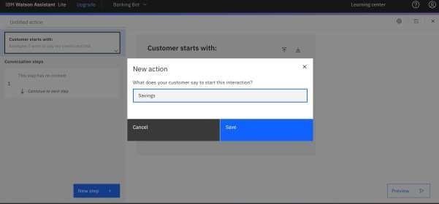

Add steps in savings action.

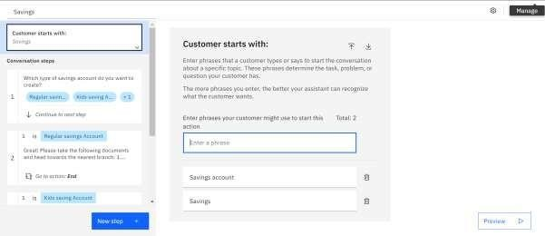

**Creating Current Account Action**

Create a new **Action** Current for the current account action.

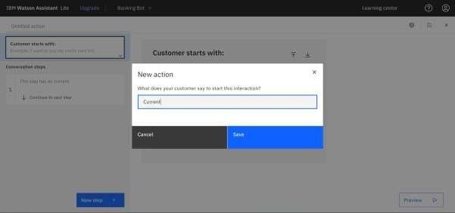

Add steps in savings action.

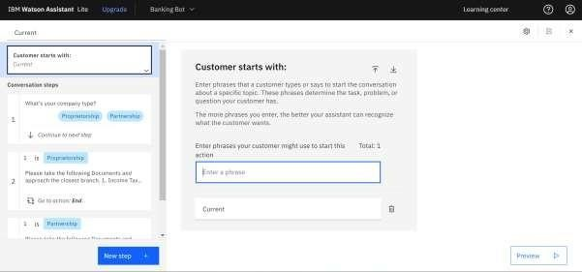

**Note:** No code for this project. So, I attached the screenshot and step to build it.